Long vowel key words and sounds
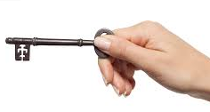

ā
a | a_e | ai | ay | ei | eigh | ey
 |  | 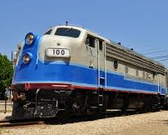 |  | 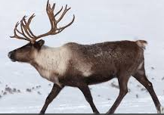 | 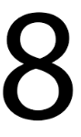 | 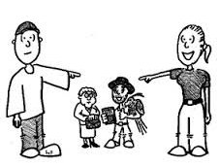
paper | name | train | day | reindeer | eight  eight | they
apron  lady  diamond  agent  basin  acorn | cane  mane  gate  snake  crate  lane  flame | rain  gain  drain  stain  grain  main  wait  complain  Spain  sustain | play  say  today  hay  spray  ray  clay  bay  tray | rein  reign | weight  sleigh  neigh  neighbour | grey  prey  obey  convey
Long vowel key words and sounds

ē
e | e_e | ie | ea | y | ee | ei
email | Chinese | yield | read | baby | see | seize
equal | here  these  complete  delete  concrete  severe  sincere | thief  field  brief  grief  niece  piece  receipt | please  leaf  clean  teach  team  dream  reach  each  heal  cream | belly  candy  daddy  penny  happy  hungry  ugly  body  angry  twenty | week  me  tree  agree  free  bee  sheep  queen | seize  either  neither  leisure
Long vowel key words and sounds
ī
ī

-y | i_e | ie | i | igh | y_e
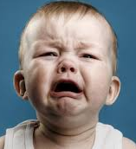 | 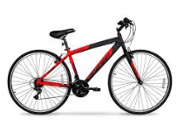 | 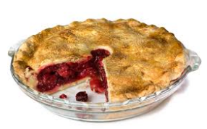 | 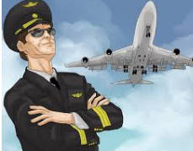
cry | bike | pie | pilot | light bulb | type
why  cry  my  fly  spy  sky  cycle  hygiene  psychology | like  bite  write  site  mine  fine  file  pile | cries  cried  fried  dries  spies  replies | island  ivory  silent  idea  diamond  giant  spider | sight  right  flight  might  delight  highlight | style  Skype  paralyze  breathalyzer  byte

Long vowel key words and sounds
Ō
ī

o | o_e | oa | oe | ough* | ow
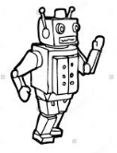 | 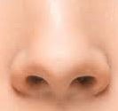 | 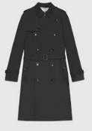 | 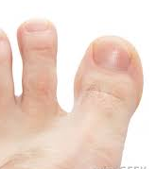 |  | 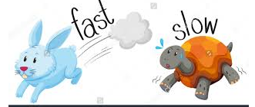
robot | nose | coat | toe |  | slow
go  also  robot  hotel  program  protect  total  moment  omit | those  globe  joke  robe  hope  hose  smoke  stroke | road  loaf  soap  roast  float  boat  coast | foe  hoe  oboe | though  although | yellow  below  snow  low  throw  crow  bow
Long vowel key words and sounds
Ū
ī

u | u-e | ou | ue | ew | ui
 |  | 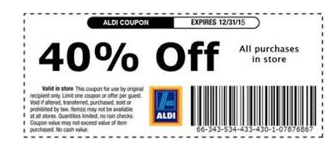 | 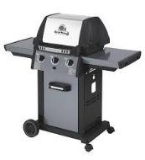 | 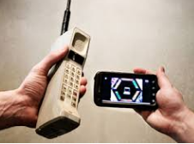
music | cube | coupon | barbecue | new | fruit
student  uniform  unicorn  duty  unit  future  human  frugal  truth  mutation | cube  huge  tube  flute  cute  amuse  abuse  mature  confuse  glue  prune  use  fuse | coupon  group  route  youth  wound | rescue  tissue  barbecue  value  cue  sue  hue  argue  **shoe  view  to too two | stew  flew  nephew  crew | bruise  suit  fluid  juice

